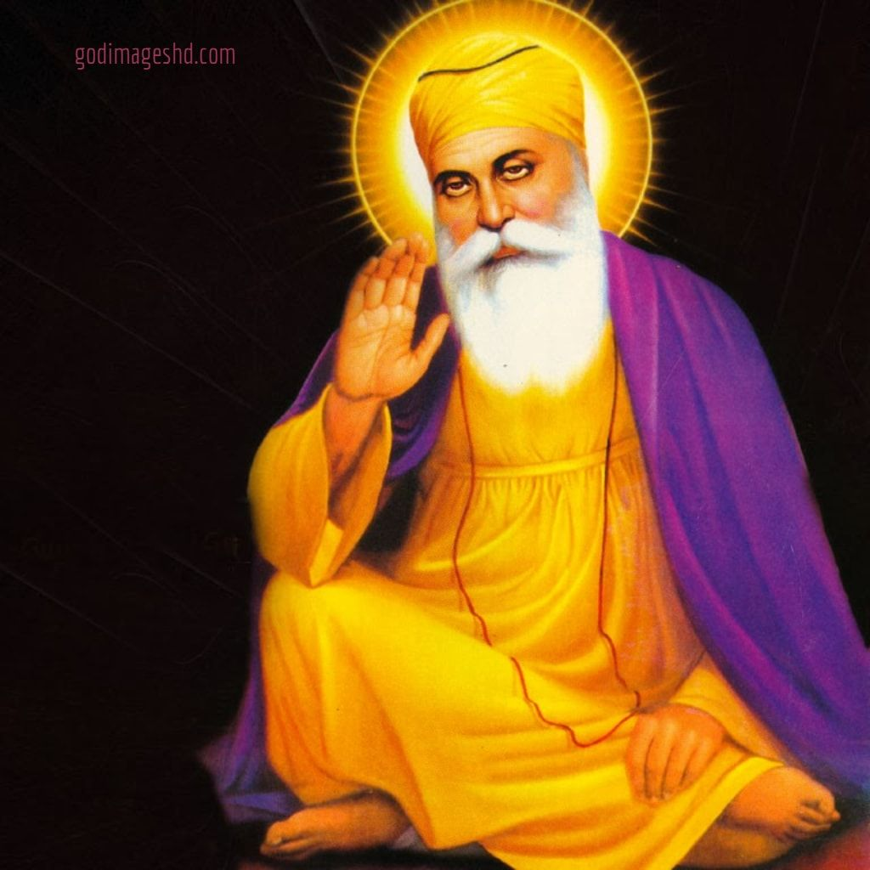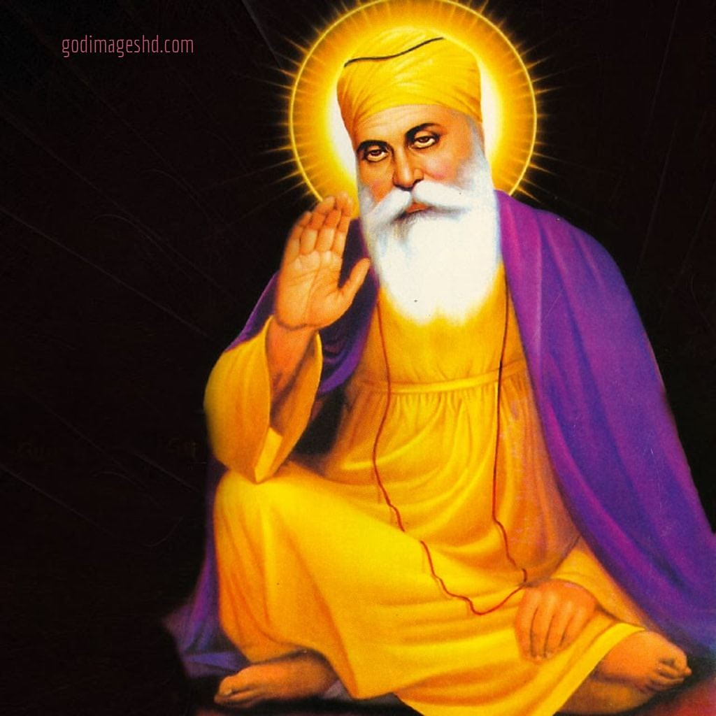

|  |
| --- |
| SRI GURU  NANAK DEV JI |
|  |
| 29th july,19  Cambridge International School  Authored by: Agam Sood |

# Title Heading



# *Quick facts*

## Subtitle

* abc
* abc2

Quote

* Abc3
* Conclusion.